**Name: Stephanie Yong**

**Date: September 7, 2022**

**Course: Foundations of Programming: Python**

**Assignment: Document Your Knowledge – Module08 – Classes and Objects**

**GitHubULR:** https://github.com/stepaidzzz/IntroToProg-Python-Mod08

**Document Your Knowledge – Module08 – Classes and Objects**

**Introduction**

In Module08 – Classes and Objects, this assignment is a true monster!!!   
Though there are a lot of references available from Assignment06 & Assignment07, the most challenging part for Assignment08 is that to combine all have learnt in previous modules into a more complex and higher level of scripts. During Module08, classes and objects have been introduced and the script itself has also incorporated with while loops, if-elif statement, try-except statement, @staticmethod, etc which learnt previously.

**Data Section**

For Constructor, instead of what shown in Figure #1, the correct syntax with two variables is shown in Figure #2:

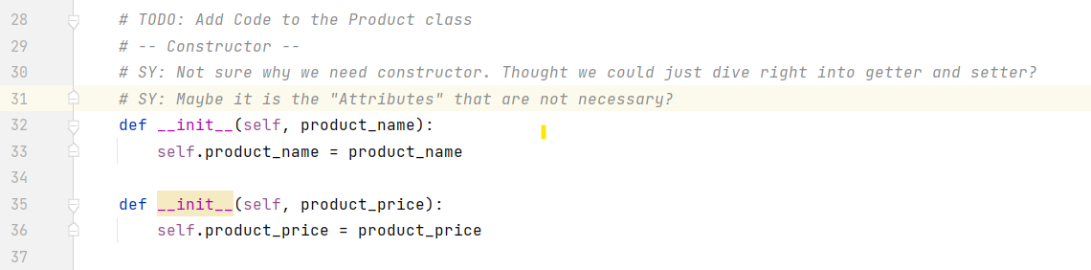

Figure #1

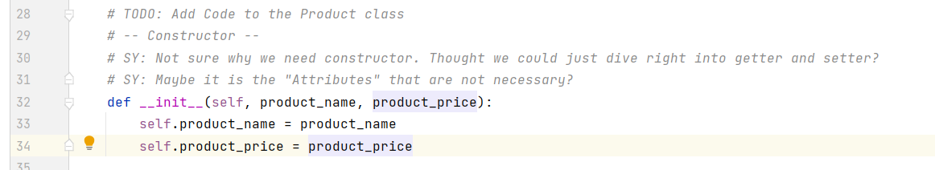

Figure #2

Challenging part for the Data section is that the Constructor was missing out and jumped right into the getter and setter which did not work as hoped. Turns out that Constructor is a necessary part of the script. Maybe it was the Attributes that is not necessary (?).

After laying down the Constructor, ran the script to test. Test result shown in Figure #3.

Before running the script, getters and setters are commented out. So the following result was coming solely from the Constructor. At this point, still quite unsure where the getters and setters are going to fit into this.

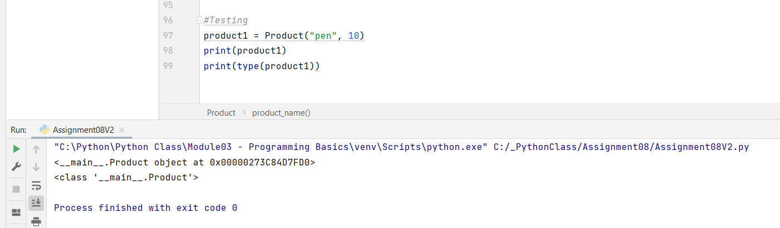

Figure #3

Another challenging part for the Data section is that Method was inserted toward the end of the section as shown in Figure #4:

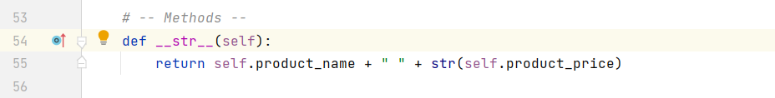

Figure #4

Methods under the Data section seems like an “output” command for the section (?).

**Processing Section**

Getting to the Processing section, copying from what was done in Assignment06 and making corresponding changes as shown in Figure #5:

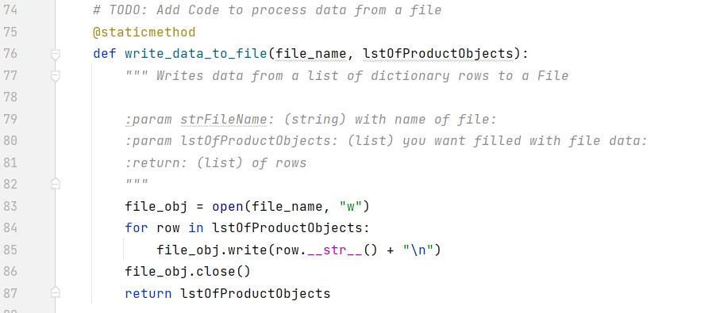

Figure #5

In Figure #5, one thing not quite getting the rationale was the following line of script:

file_obj.write(row.__str__() + “\n”)

Not sure why “row.__str__()” was used instead of the “product” and “price” like how it was done previously (?).

Under the Processing section, another line of script that I am quite unsure of would be the highlighted line shown in Figure #6:

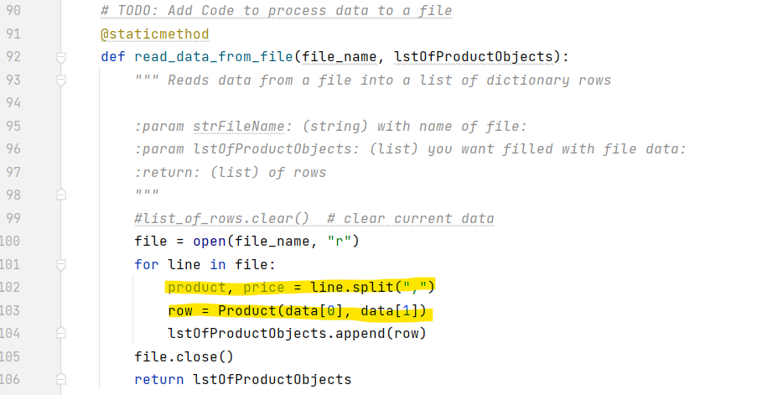

Figure #6

Also, for Processing section is one of the biggest mistakes that made in previous version is that totally different sets of script were used as shown in Figure #7:

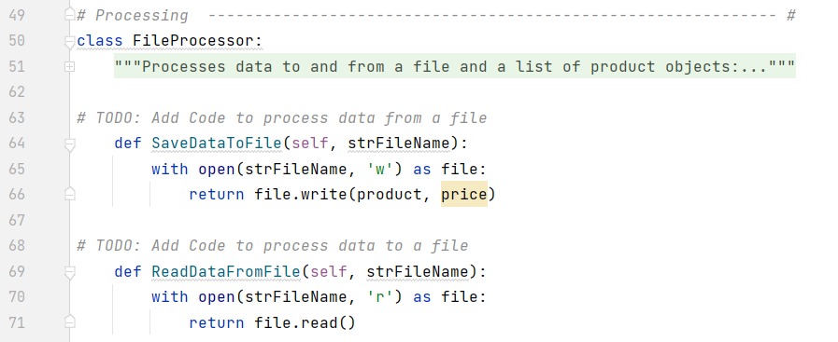

Figure #7

Regarding the different sets of codes shown in Figure #7, still unsure how these are not working as planned.

**IO Section**

For the IO section, Assignment06 has been provided a great reference source. Again, changes have been made to the script to fit the purpose of Assignment08. But there are quite a few confusion or line of script that I am not making association with as shown in Figure #8 and Figure #9 below:

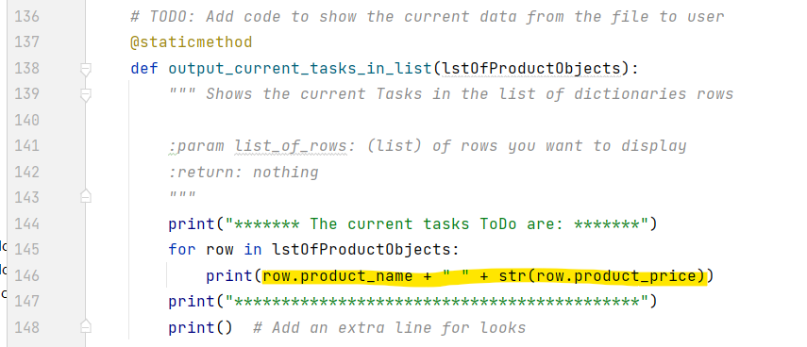

Figure #8

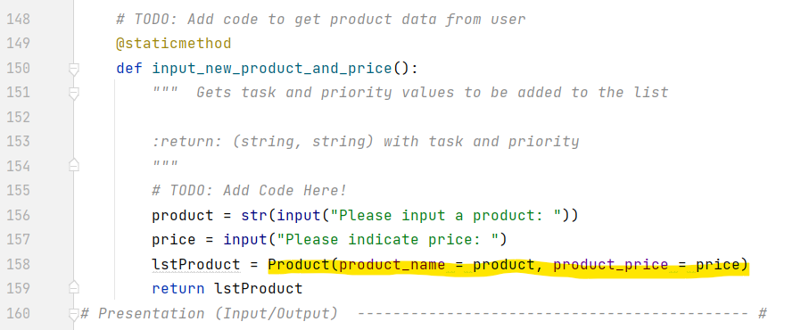

Figure #9

**Main Body of Script Section**

Under the Main Body of Script section, my favorite while loop with if-elif statements are implemented. In referencing to Figure #10, try-except statement was originally inserted at where the pink arrow is pointing instead of the very end of the section. The though process was trying to capture error immediately when the error was made. However, the script obviously has a different route in its though process and when the try-except statement was insert right after the line of “choice_str = IO.input_menu_choice()”, the script indeed ran through the error message even though the input was correct (i.e. even inputting 1, 2 or 3). So, later on, figured that the except statement indeed needs to be put at the end to “scoop up” any error input made.

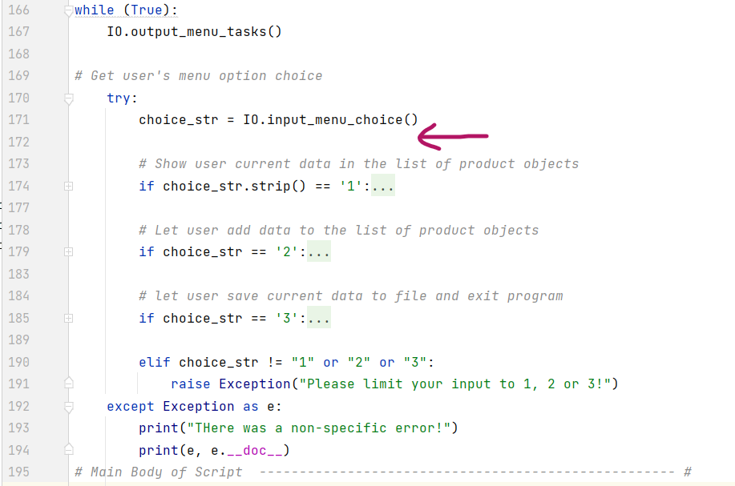

Figure #10

**Test Run in PyCharm Environment**

Figure #11 shows that error message generated if input is not 1, 2, or 3 as specified:

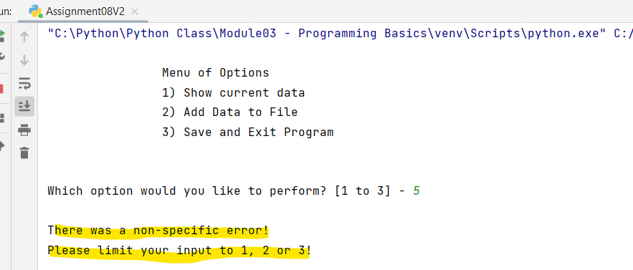

Figure #11

Figure #12 shows the input command of 2 and 1 with adding and showing items respectively:

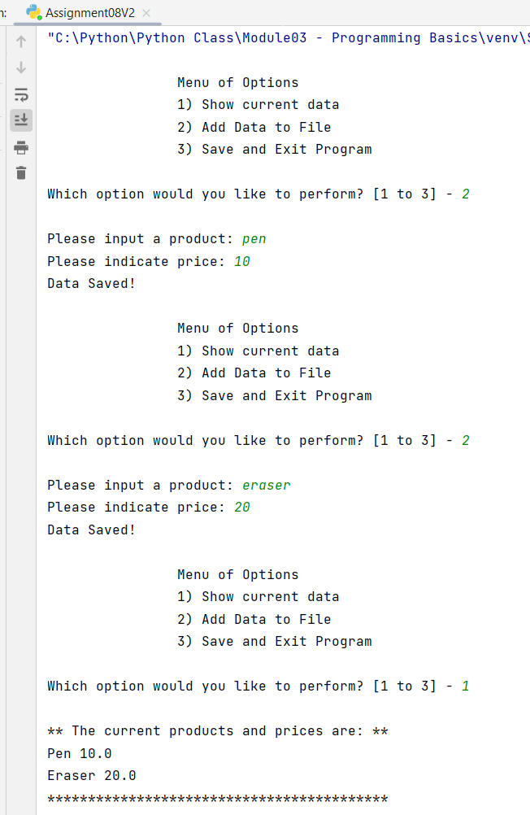

Figure #12

Figure #13 shows that by inputting command of 3, the program exited.

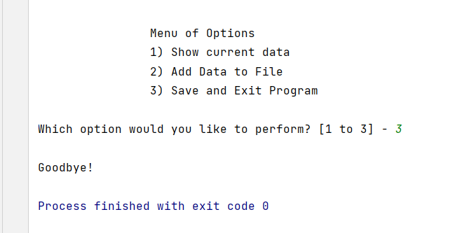

Figure #13

Figure #14 shows the products.txt appeared as the script ran and within the text document of Figure #15, the corresponding input items were found:

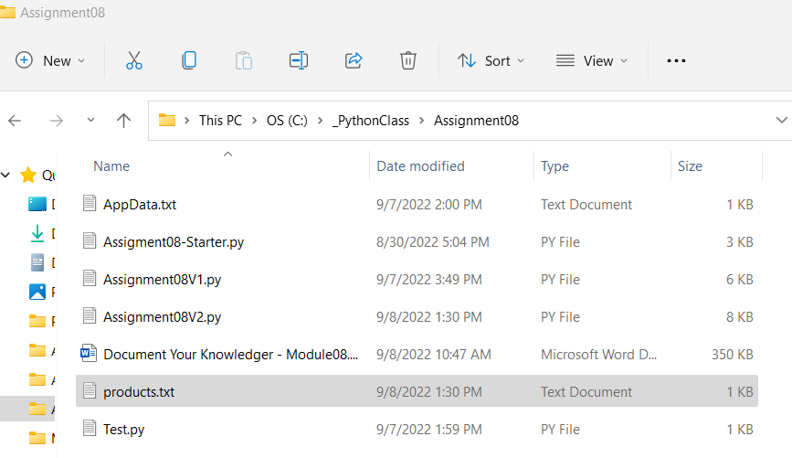

Figure #14

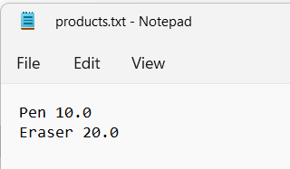

Figure #15

**Test Run in OS Command Environment**

Figure #16 shows the script ran in OS command environment with different input command of 1, 2, and 3:

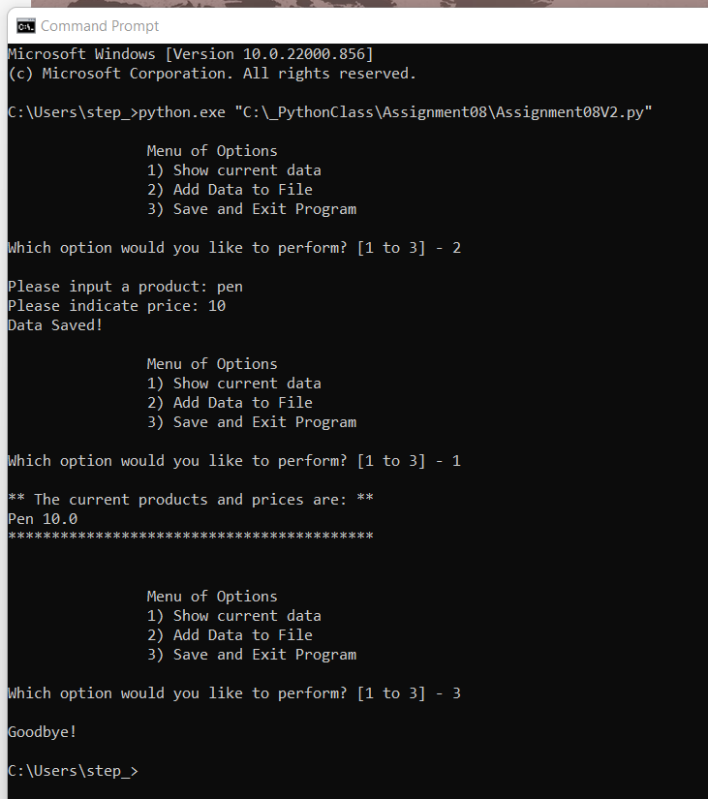

Figure #16

**Conclusion**

Assignment08 is challenging. I tried to come up with the script on my own without success. So, I did reference to the video provided by Randal to complete the assignment. And, even now the script is running, there are lines of script that I am still quite unsure how it is the way it is. But after working on Assignment08, it definitely provide a better insight to how a class and getter and setter work. Now it gives me a better picture of how each of these components link to each other.